Q1.Find students whose zipcode is 63109 and school code is 102
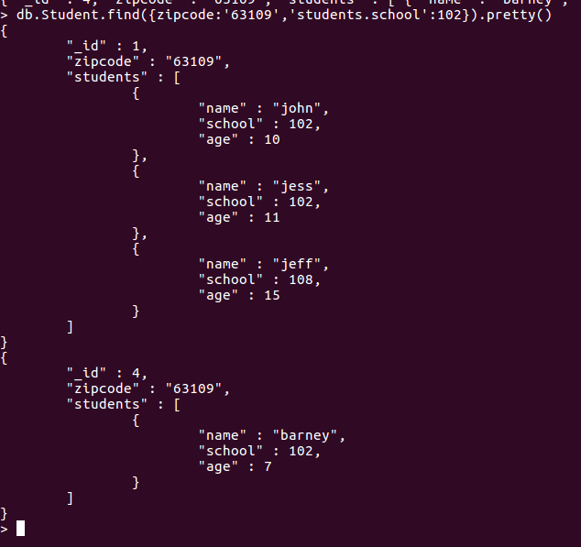

Q2.Update each student code from 100 to 101 where zipcode is 63109.
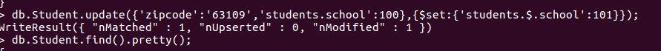
Q3.Insert two more students in students array where zipcode is 63110.
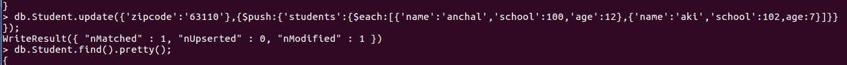

Q4.Remove an element from students array whose age is greater than 15
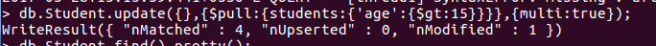
Q5.Find out the total price of books group by their authors and language
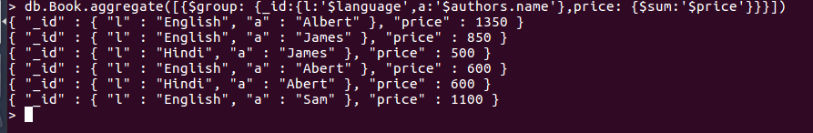
Q6.Group by author name and then by language and display total_price and no of books published on the publish date “05/04/2014”
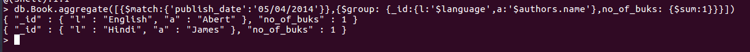
Q7.Display only blog title and comments in the output document using aggregate

Q8.Create compound index on price and author's
name and show created index list
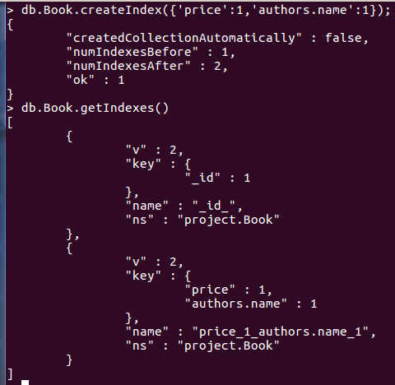

Q9.Create text index on books title and text search for any book title
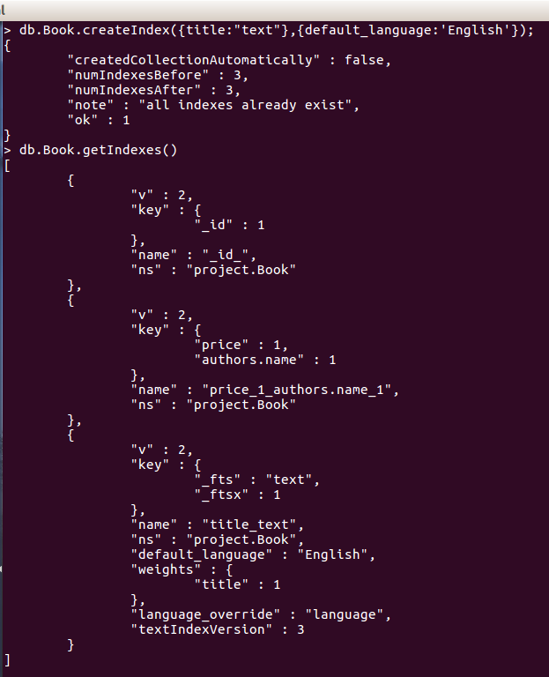

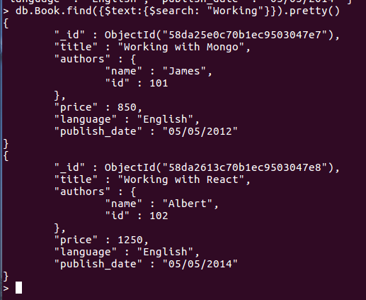

Q10.To Find The user having tweets count and follower count greater that 1000

db.getCollection('influencers').find({$and:[{tweets_count:{$gt:1000}},{followers_count:{$gt:1000}}]})

Q11.Write a query to find user_id where retweet count > 10
db.getCollection('tweets').find({retweet_count:{$gt:10}})
***********
db.Student.find({students:{$elemMatch:{'name':'aki'}}}).pretty()
> db.Student.update({zipcode:'63109','students'{$each:[{school:101}]}},{$set:{'students.school':100}},{upsert:true})

db.inventory.aggregate( [{"$match": {"item" :{ "$ne" : null } } }, {"$group" : {"_id": "$item", "count": { "$sum": 1 } } }, {"$match": {"count" : {"$gt": 1} } }, {"$project": {"name" : "$_id", "_id" : 0} } ])

